User manual

Compiling it with gcc -lpthread -o 4471 4471.c

Running it with ./4471 20 30
4471 is compiled program.
20 is the first variable, numthreads - an integer value that specifies how many threads will be created.
30 is the second variable, increment - the number of integer values that each thread will work with.

Result:
Since my student ID mod 3 = 1, so this program compute the sum of the integers.
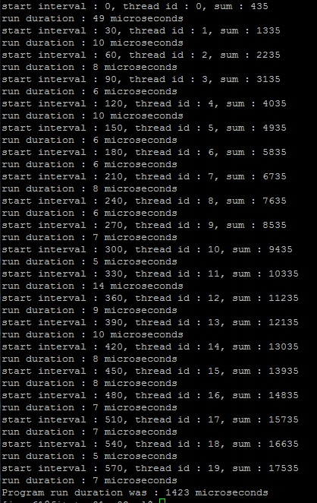

Limitation:
When the user typed too large number of increment, the sum of the array might be negative.
Because in program, I declared int variable for sum, it has its range [-2147483648, 2147483647].
When the sum of the array is out of that range, it might get wrong result.